Jerusalem

Jerusalem city
Jerusalem is the capital of Israel.
Jerusalem is a very old city which is holy for the 3 main religions: Judaism, Christianity and Islam.
Jerusalem is the religious and national center of the Jewish people, since king David's days.
Jerusalem is situated on the “Judian” mountains, and has no seashore.
Modern Jerusalem was established in the middle of the 19th century.
Today Jerusalem is the second biggest city in Israel.
The government and the parliament reside in Jerusalem.
After the independence war in 1948, the new and old Jerusalem were divided and were reunited again after the 1967 war.

1. Is Jerusalem the capital of Israel? Y/N
2. Is Jerusalem more than 100 years old? Y/N
3. Is Jerusalem the biggest city in Israel? Y/N
4. Does Jerusalem have a seashore? Y/N
5. Is Jerusalem a holy city for many religions? Y/N

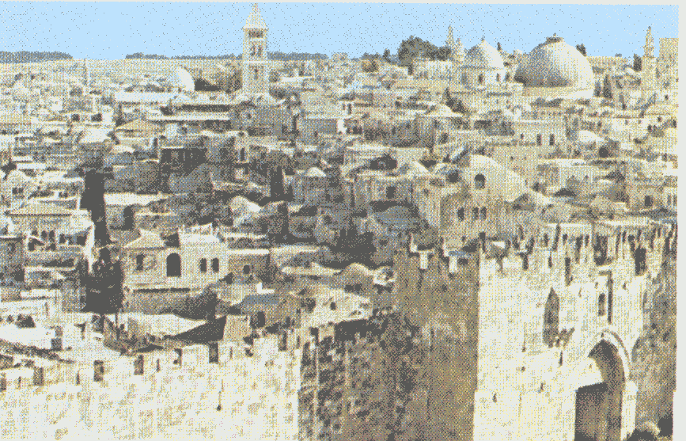
Bibloigraphy
Jerusalem of gold.

Year Page
1985 63

JERUSALEM-A LOOK FROM ABOVE.

