B.H

Anne Frank was born in June 12,1929.
She was the second daughter of Otto and Ehdit Frank.
Anne and her sister, Margot grew up in Germany.
The friends of the Frank family were from different religion and different faith.
Otto served faithfully in the Germany army, in the time of world war І, but in the beginning of 1930, the situation of the Frank family changed.
Otto left to Holland in order to open a new branch in his brother’s company. Its name was: Datsh Opkata.
Lees than a year later, Ehdit, Margot and Anne joined him.
In the middle of 1930 the Frank family started a normal life in their new house.
The girls went to school, the parents went to work, and they became friends with Jewish and non-Jewish.
The Jewish had to give away their businesses and Otto Frank gave it to his Dutch friends.
Unfortunately the thought of Frank family that they had a protected place from the Nazi was wrong, when in May 1940 the Germans invaded Holland and the Frank family had to live under Nazis’ restrictions again.
In 1942 there were many Jews arrested.
The Frank family started to think of hiding places.

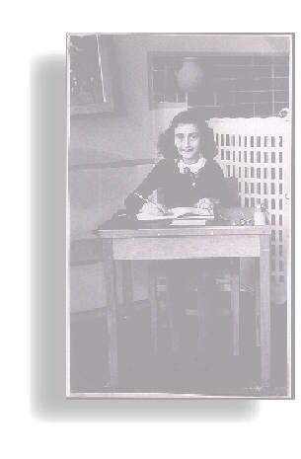
They had a place, above Otto Frank’s office that included a few rooms.
When they prepared the hiding place Anne was 12 years old.
In the year, 1942, on July, Margot got a message about her transference to the “ Labor Camp”.
The Frank family understood that they needed to hide even though their hiding place was not ready yet.
They took their posessions and left notes that testified that they were not in the country. After that posseion they moved to their hiding place. On August 4, 1944, at 10:00 o’clock the worst happened.
Nazi policemen came to Otto Frank with news that Jews were hiding in the place.
They came close to the book cupboard that concealed the hiding place.
The family were put in chains and sent to camps. On August 8,1944 they were moved to the transition camp, and after one month- On September 3,1944, they were moved to the destruction camp- Aushwits that was in Poland.
In this place she dead. Anne father’s was the only one who service in the holocaust. After the war Anne’s diary found out, and became a popular book in all the language. This diary is the sellest book after the Bible.

Order the words
oott
- aryid
- dinghi acepl
- nena ankfr
- nzisa
- jwishe
- baorpdcu
- grmnyaer
- stericrionst
- edith
- mraogt
- lobra amcp
- dnalop

Find the answers in the tablet below.

h | c | u | p | b | o | a | r | d | l | r
i | o | m | a | r | g | o | t | n | a | e
d | i | a | r | y | r | a | b | a | b | s
i | h | n | g | a | t | d | i | z | o | t
n | g | n | j | o | t | t | o | i | r | r
g | i | e | g | m | j | o | m | s | c | i
p | u | f | y | e | n | e | p | d | a | c
l | e | r | h | h | r | z | w | k | m | t
a | r | a | p | d | z | m | u | i | p | i
c | f | n | s | i | c | k | a | f | s | o
e | c | k | n | t | b | d | w | n | l | h
r | p | o | l | a | n | d | s | a | y | s

Answers
1. oott (Otto)
2. aryid (dairy)
3. dinghi acepl (hiding place)
4. nena ankfr (Anne frank)
5. nzisa (nazi’s)
6. jwishe (Jewish)
7. baorpdcu (cupboard)
8. grmnyaer (Germany)
9. stericrionst (restrictions)
10. edith (Ehdit)
11. mraogt (Margot)
12. lobra amcp (labor camp)
13. dnalop (Poland)

Find the answers in the tablet below.

