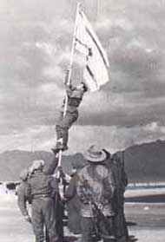
Eilat was freed in 1949.From an unsettled place it became a successeful city and an attractive tourist location.
Eilat was freed in a military operation. It was important to free Eilat because in Eilat there is an approach to the Red Sea.
Since then every year the residents of Eilat celebrate Eilat day .Eilat was developed: buildings were built and shops and schools were opened. A lot of hotels were built and roads were paved which connects Eilat to the center of Israel. Eilat became an internetional tourist location.There is an airport too.
Today, there are about 50,000 people in Eilat.
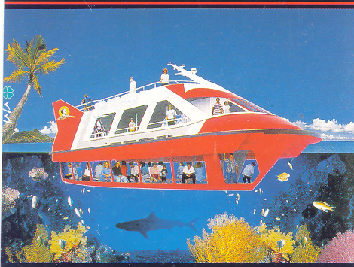
It is the most southern city in Israel.As was said before ,Eilat is the only approach of Israel to the Red Sea. This sight is the most beautiful sight in the world. The port of Eilat is very important to the Israel economy. There are goods from the east that arrive in Israel.
BY TEHILA HALPER
HADAS DUHAN
ADI VICHTER

