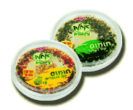
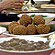
Israeli food
What is actually the Israeli food?, is there such a thing like Israeli food? and if there is, what is it?.
The Jewish people cook Israeli food. Food that is mad of ingredients that always grew and grow in Israel. These ingredients are typical of Israel and of the Jewish people.
The humus isn’t Israeli and neither the cactus. The cactus is actually a new immigrant that came from South America 500 years ago. Like the cactus the Arabic humus came from South America too.
On its way it had a few changes, and got original Israeli qualities.
The Israeli food has been influenced by the Jewish food. The Jewish food has been influenced by the environment where it grew.


By: Anat Scheinowits
Maayan Yaso
Liat Ainhoren
Nitzan Gurgi
Liron Bar-Sohar.


The humus-our pride!
A person does not have to be smart to make humus.
Despite the high reputation of the humus, humus is nothing but a paste that is made of soft humus grains that were in water, and any normal person can make if he stick to the recipe.
The humus came from the Arabian culture and ended as the national food of Israel. You can find humus in every house in Israel, and the Jewish people love it.
The humus origin is in Syria, our northern neighbor.
200 years ago researchers from Europe told us about a Syrian delicacy, which they called, "Denmark's pearl."


From Syria the humus spread to Jordan and to Palestine of those days, but it didn't spread into Egypt because of the bean fear"."
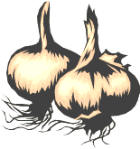
Later, the humus had some changes until it become the Falafel we all know. The Falafel was invented only in the beginning of the current century. In the liberation war the humus was liberated with Jerusalem. Since then the humus has been conquering Israel like a storm.


Recipe for humus:
The process of making humus is very simple:
First (you have to) put the humus grains in water, for about a night. Then (you) cook the grains until they're soft enough. Then (you) put Tchina*, lemon and garlic in it- and there you go-you have humus.
*The soul of the humus is the Tchina.


Bon appetite!!!

