Ingredients:
-One kg of chickpeas soaked in water all night.
-Half a glass of chopped parsley.
-One chopped onion.
-3 chopped pieces of garlic.
-2-3 full spoons of flour.
-One full spoon of cumin, and paprika (sweet or hot by the taste).
-One flat spoon of table salt.
-One package of baking powder.
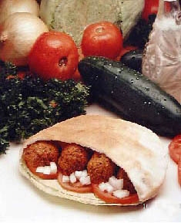
-Some water.
-Oil for frying (not olive oil).
Preparation:
-Chop onion, garlic and parsley (not togetner) and drain the fluid.
-Drain the chickpeas, and grind them in a food-processor.
-Before frying, mix all the ingredients, and make balls from the paste. If the paste is too thick put some water. If the paste is too watery add some flour.
-Now, fry the balls in deep oil.

Good Luck!

Ingredients:
- One cup of natural (raw) Tehina.
- One cup of water.
- Juice from half a lemon.
- One crashed piece of garlic.
- 1/4 package of parsley.
- salt
Preparing:
Use a mixer or a food- processor.
Add water till the mixture is smooth.
Add salt, lemon juice,(using lemon salt is recommended). Add garlic and at last add the chopped parsley, mix with a spoon.

