Fashion in Yeshurun

Maayan Sulami, Yael Kochavi, Orit Yichye, Yaara Shalom

Hello, we are girls from Yeshurun.
Our school is a religious school and therefore we should come to school wearing long sleeved shirts or short sleeved shirts covering the elbow.
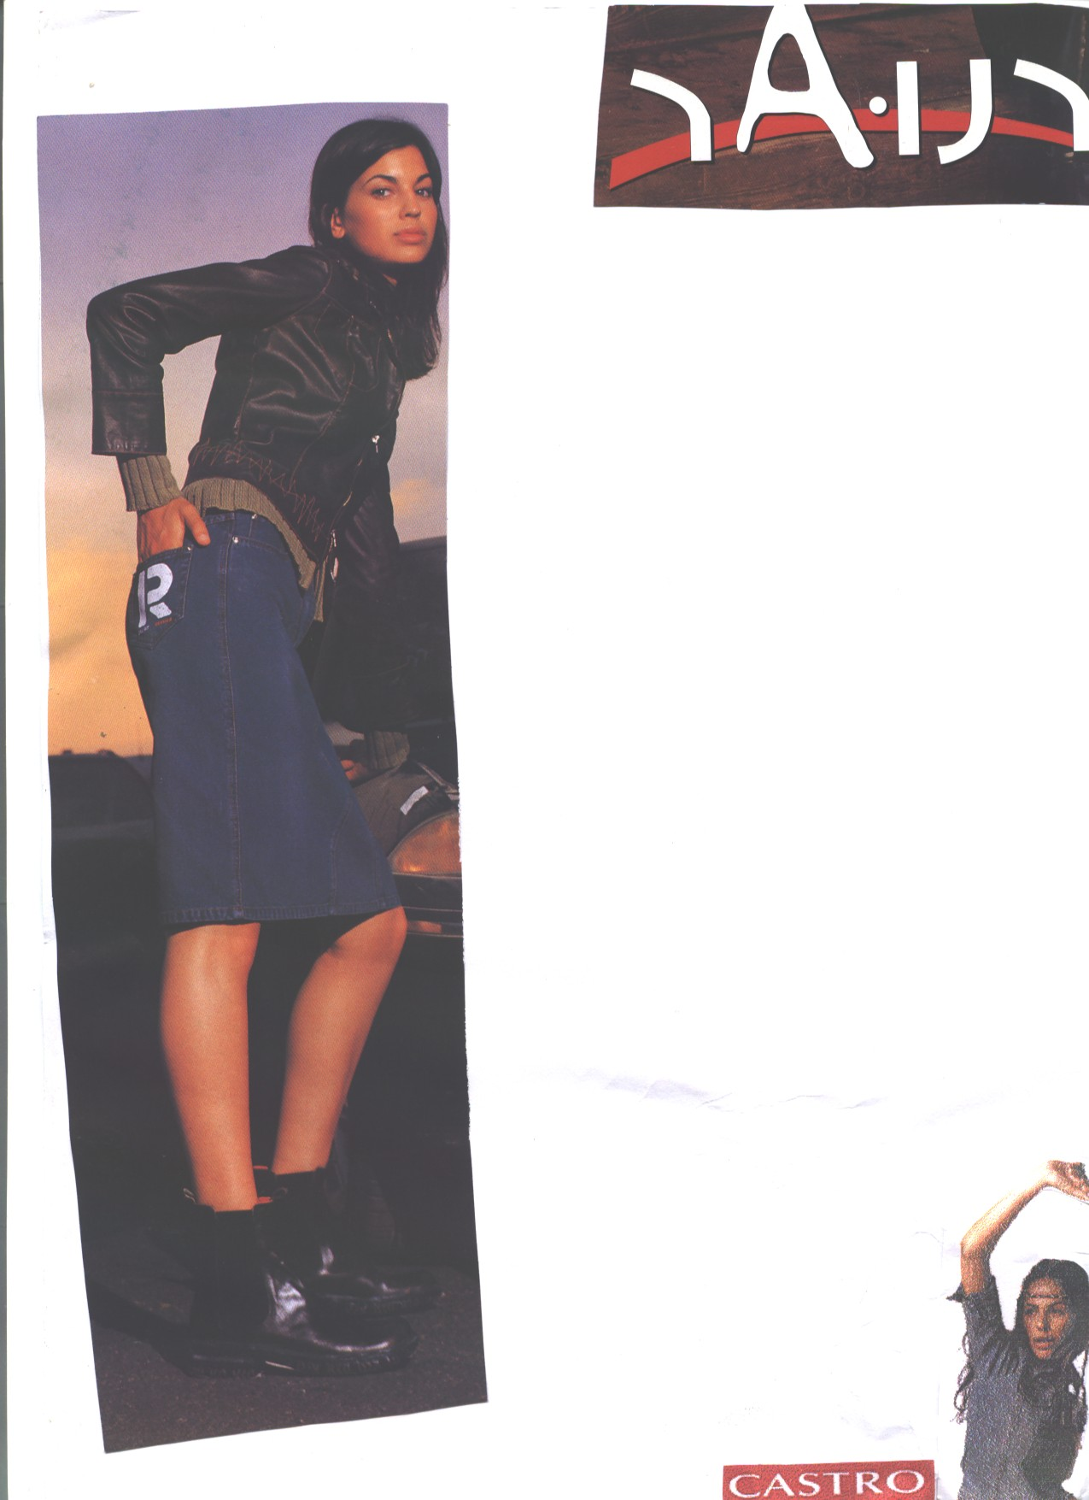
The colors permitted are: grey, blue, red and brown. We can find these shirts in a lot of stores. Most of the girls at school buy their clothes in: FOX, TNT, MANGO, CASTRO,etc...
We should wear skirts from the knees down in colors: black, grey, blue, and green.
At the beginning of the year our school had a deal with Fox.
The deal was that the company will sell shirts to the girls on special cheap prices. It was worth it to Fox because the number of the girls at school is not less than 550.
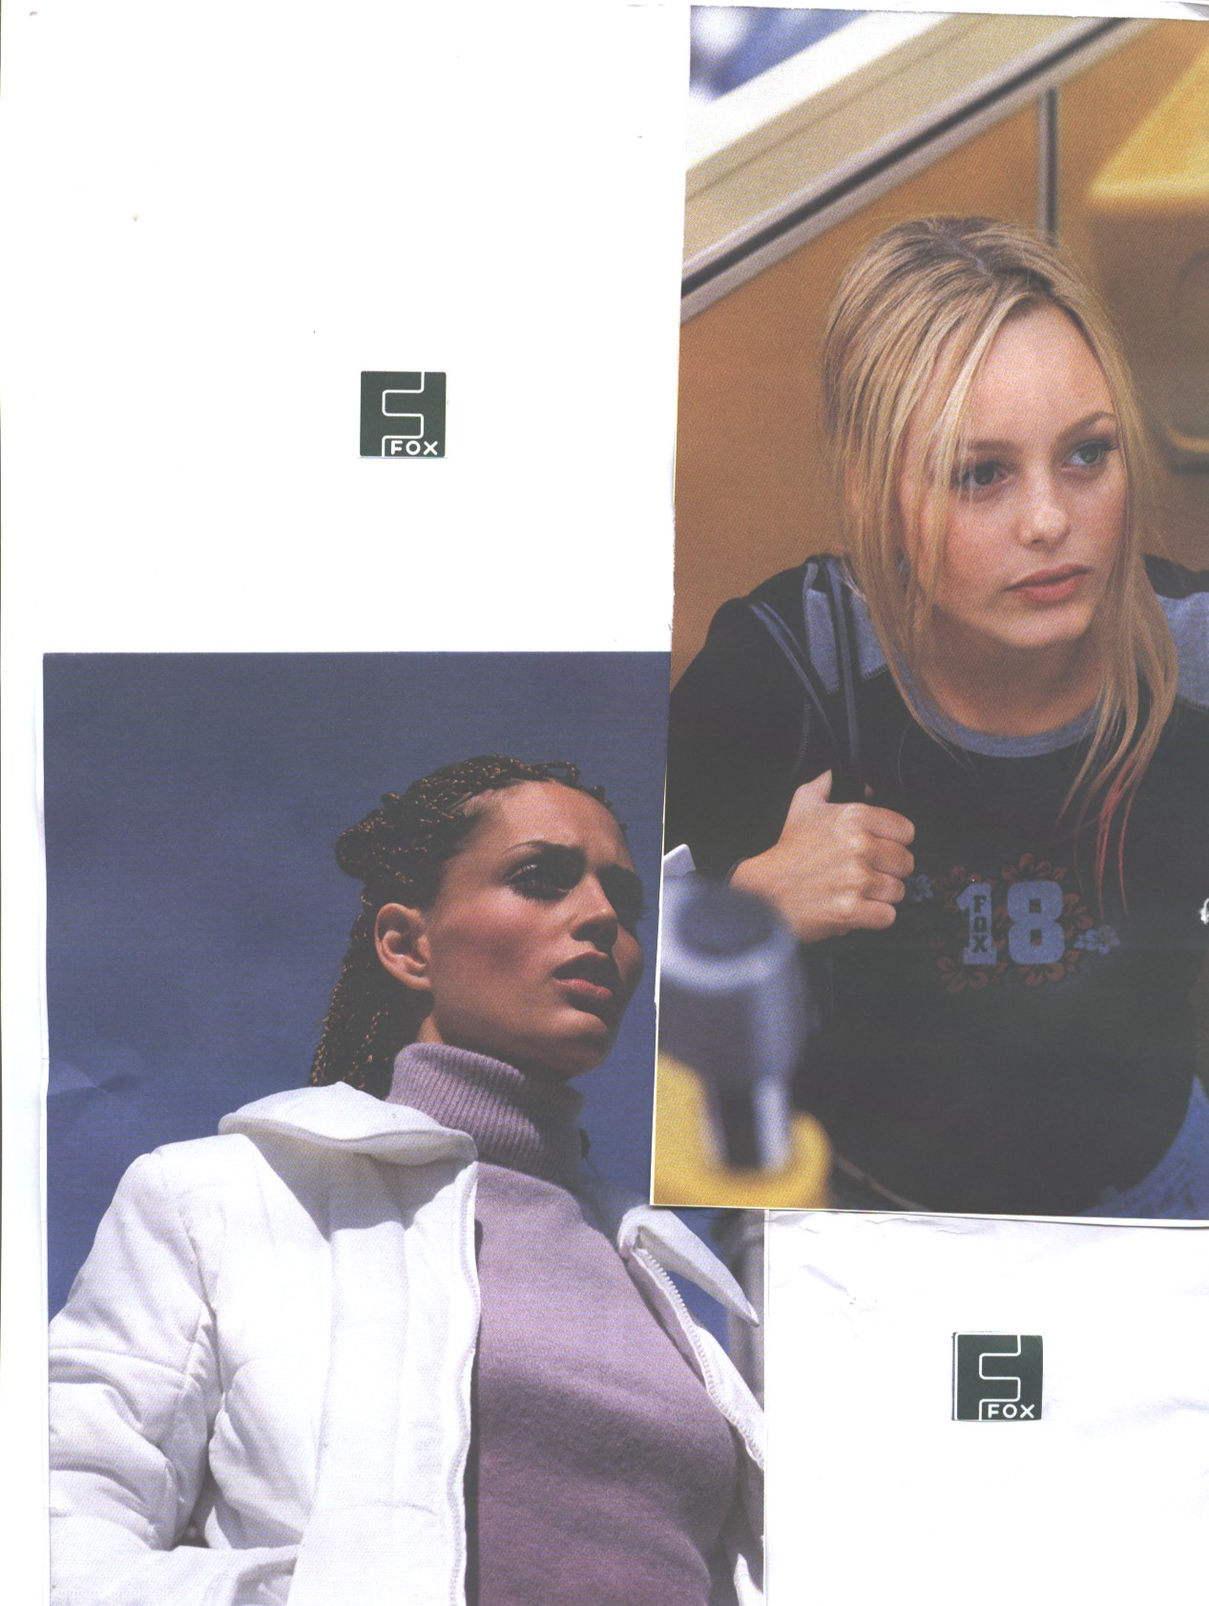
The school promised to sell many shirts and that’s what happened.
The designs and the colors were chosen by representatives of the school which met with the C.E.O of the company. They matched the designs and the colors, The designs are not like regular school uniforms, therefore the girls wear them not only in school but after school too...
In Yeshurun most of the girls are dressed very nice.
The fashion in Yeshurun is based on many kinds of well known clothes companies, for example: CASTRO, TNT, ZARA, and more...

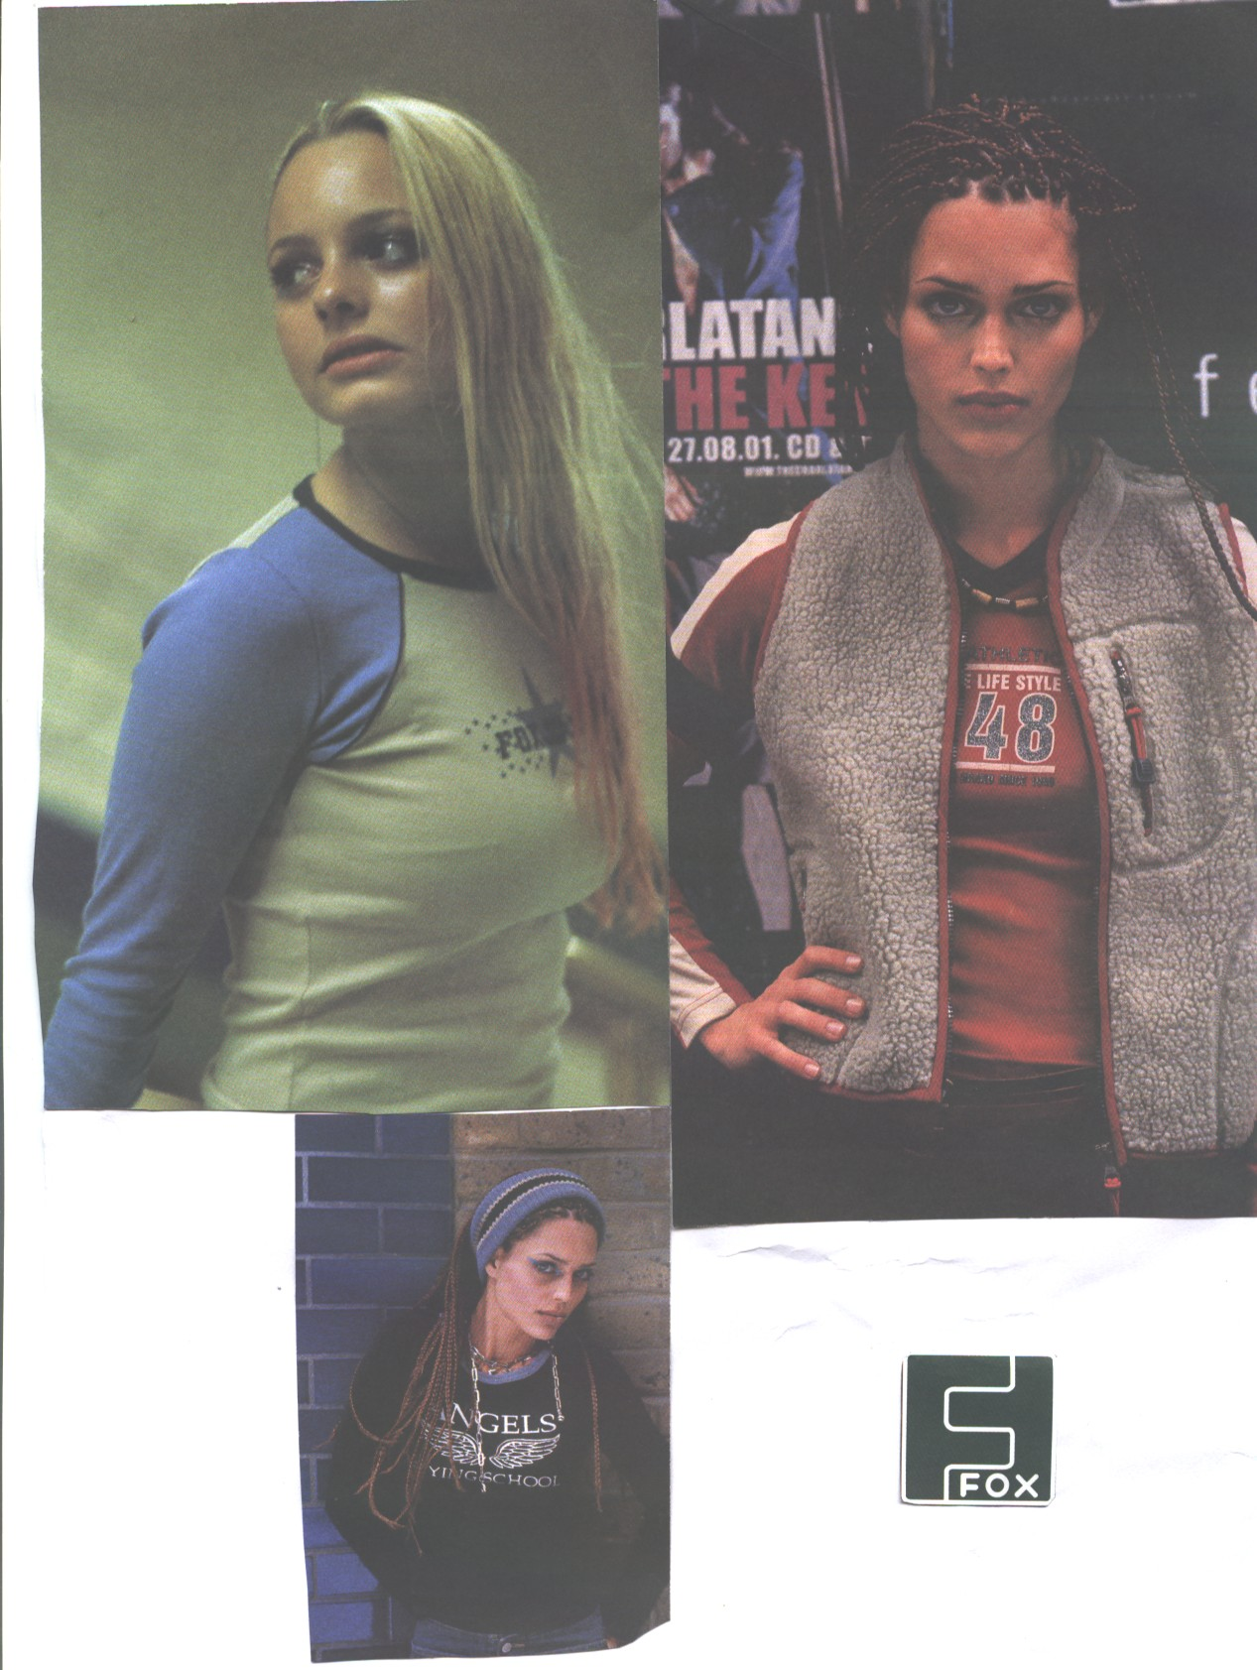
We did a survey in school and we asked some of the girls a few questions:

1.Which clothes do you like to wear? (elegant or sporting).

2. Which company in your opinion has a good quality in clothes?

3. Which company in your opinion, is the best? (Castro, TNT, Fox, Zara...)

Answers of the survey:
1. *Elegant- 63%
*Sporting- 37%

2. *Castro- 27% *Zara- 11%
*TNT- 23%
*Fox- 39%
3. *Castro- 25%
*TNT- 53%
*Fox- 12%
*Zara- 10%

Most of the girls really invest in their clothing for school, and some of the girls wear as they say:
“what ever they pick up...”
Since we are in a religious school, the girls usually wear elegant clothes on Friday nights, and on festivals and special ocasions.



Find 8 different details in the two pictures:

