There are a lot of important historical events that happened to Israel during all the years.
We chose a few events and here they are:

On May 14, 1948 all the Israeli citizens gathered together to declare Israel a free state.
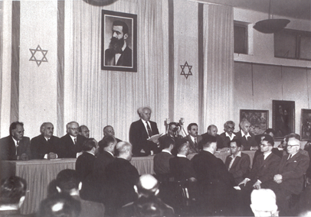
At 4 o’clock p.m David Ben Gurion (our temporary prime minister) read the Declaration of Independence.
After that, he and the leaders of Israel, signed the
Declaration of Independence.
Then, the whole country celebrated our independence day.

Soon, Arab armies started shooting at us.
They didn’t understand that we had a free country and as a result ,the war of independence started.

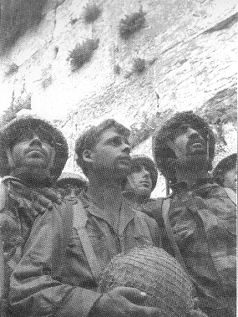
Israel, Egypt, Syria and Jordan were involved in the
Six Day War-which lasted from the 5th until the 10th of June.
The Israeli airplanes attacked the entire military airfields in Egypt and Sinai. During 20 hours of battles, the breach burst on Syria line, and Tzahal conquered a broad strip of Ramat- Hagolan, on 10 June.
The war ended in Israel’s victory.
The war brought Israel control of land 3 times its size then the areas before 1967.

On 6, October 1973 the Yom Kipur War between Egypt, Syria and Israel broke out. The war ended in January 1947. There were many dead soldiers to all 3 countries: Syria-3500
Egypt-1500
Israel-2350

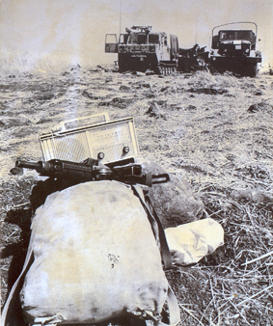

In 1967 Israel and Egypt agreed to sign a peace agreement.
The ceremony of the signing in the White House was impressive and festive.
The three anthems were played and later the president Menachem Begin and the president of U.S.A- Jimi Karter, singed the history agreement.
The peace agreement said that Israel should get out Sinay and there would be peace between the two countries.

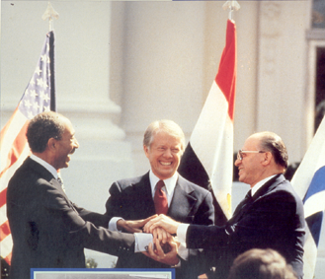

Written by: Efrat Elimelech, Avital Alter, Racheli Blank and Yaara Sobol

A I c w f s I xd a y z m t b q a

T s n v g h w s e j o y u c c b s
A r u d l y a y I n m a l v p p t
D a b l e n r r e o k x t j e s s
A e t s c p s I l m I a z b a r l
A t n 8 s a e a u o p 8 s I c w t
S s j 4 p r bn f p o 4 u a r e u
R t g 9o p q c d l r l b q v t h
A t f 1 s I n a y a k n c n u g c
W t I e k l e bx p n k z yx f a
N e ht p y g e qm l c b I j e r
Am s u e t s c a n a l e h l e a
F n I g e b me h c a n e mb j t
N I e l p m t t n u o m y nr m l
The words:
1.Independence 8.Yom Kipor 15.Wars
2.1948 9.Egypt
3.Israel state 10.Syria
4.Six Days 11.Soetz Canal
5.Sinay 12.Anwar Saadat
6.The house mountain 13.Menachem Begin
7.Parachutists 14.Peace

