T.G



We decied to do the article about:
Lack of water in our country.

So what is the water situation in our country?

In the last few years there wasn’t enough rain and because of that the kinneret water level got down and we didn’t and stiil don’t have enough water in the country.

The kinneret today.
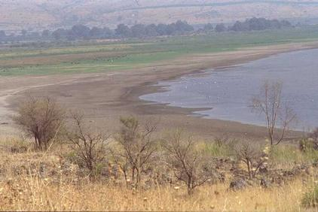

T.G.

There are some solutions:
*To bring water from other countries.
* To desalinate the water.
*(Pray to God for rainy winters.)

What is stopping us from doing it?
*It’s very expensive to desalinate water, and we don’t have enough money in the country to do it.
*We don’t have enough money to pay to the countries if they bring us water.

The level of the kinneret at 1996 was –211.51.
At 1998 the level of the kinneret was –212.53
At 2000 the level of the kinneret was –213.17
At 2001 the level of the kinneret was –214.87
(Take from: www.tipa.gov.il/consume.ntm)
According to this data we can see that about every 2 years the level of the kinneret gets down and if we wont stop it we must start economize or else we will not have enough water!

T.G.
The soultions that we suggest:
To economize water.
If you don’t have to use water – don’t waste water !!!
And if you have to use it so do it with the least water you can. For example: gardens at night,
When you are brushing your teeth you should close the top.

So…


By: Hadar Mantsur
Keren Hershkovitz
Malki Franko
Shirel Tovim
Tchiya Dopelt

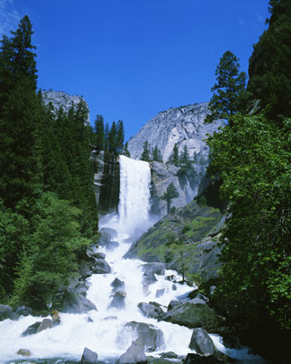
T.G.

R | W | G | D | W | A | Q | W | E | R | E | T | Y | D
E | A | A | R | A | K | I | N | N | E | R | E | T | E
D | V | R | O | T | K | L | D | P | O | I | N | U | S
A | E | D | U | E | C | O | N | O | M | I | Z | E | A
E | R | E | G | R | J | H | G | F | A | K | C | A | L
L | E | N | H | D | B | S | C | R | A | Z | Z | L | I
H | T | S | T | Y | C | X | K | I | N | E | R | E | N
S | N | A |  | V | A | B | N | M | P | O | I | V | A
I | I | E |  | M | A | R | L | F | A | U | C | E | T
F | W | S |  | E | G | R | P | T | Y | F | U | L | E

The words you need to find are:
*Water *Drought
*Faucet *Gardens
*Kinneret *Sea
*Desalinate *Winter
*Lack *Fish
*Economize *Wave
*Rain *Leader
*Pray
*Level
Good-luck!

