Maccabi Tel Aviv is the symbol of Israeli Basketball.
The group won the Europe – cup 3 times, and this year they hope to get to the final four and win the campionship again.

The group consists of about 10 mian players.
Some of them are foreign (not from Isreal).
We chose to interview 2 Israeli players: Nadav Henefeld and Gur shelef.

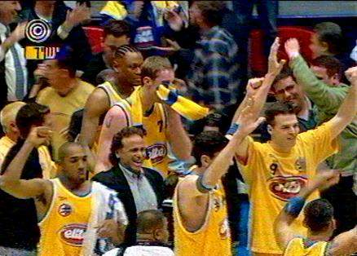

An Interview with Gur Shelef:

Hello !
Where & when were you born?
I was born on January 10, 1967 in Tel Aviv.

What is your height?
My height is 2.01 Meters.
(Oho! I can see you are a very tall man. Yes I am.)

Which teams did you play with?
Hapoel givataim, Macabi Ramat Gan, Hapoel Emek Israel and Hapoel Galil Elyion.

How long are you with the team?
3 seasons.
(It is very long time!)

In which team did you play well, and which titles did you get?
I played with Macabi Tel Aviv, and I won two championships.

Are you the first in your family who plays basketball?
No, I am not. My father played basketball.

In which championships did you take part?
I took part in the Europe championship.
(It is excellent !!!)

Thank you very much.

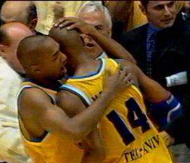

An Interview with Nadav Henefeld:

Nadav Henefeld is the captain of Maccabi (elite) Tel Aviv, and of the Israeli team.
Most of the people think that he is a shy and a closed man, In this short interview we will try find out more about Nadav. Let’s see if we can do that.

Here are a few details about Nadav:
Nadav was born on June 19, 1968 in Ramat Hasharon. His height is: 2.00 m, and he is single.
This is his 11th season in Maccabi. His two points shooting percentage is: 62.5%, and 48.1% from the penal.

Q: It sure was a strange season for you. On one hand, you suffered from a back injury, but on the other hand, we witnessed some of your best performance, how do you explain it?
A: In the past few weeks my back injury got better, but I’m still not in a full shape.
Even though I suffered physical pain, I give all the credit to my family that supported me.

Q: Can you describe the last minute of the final game last year, and your feeling after wining?
A: All the pictures of the whole season, and my entire thoughts passed so fast in my head.
In the last minute, we knew we were going to win and to take the championship, but we waited for the last second just to be sure, and then we started to celebrate our wining. All the audience of Maccabi got down, and we had the time of our life, it was fantastic.

Q: Last question. How do you want people to remember Nadav Henefeld thirty years later?
A: Who will remember me? It doesn’t depend on me, it depends on other people.
I hope that people will like me and will remember my contribution for the basketball.
A person that knows me well knows what kind of person I am.

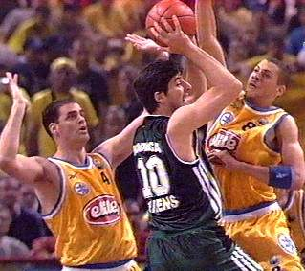

Puzzle

Try to find all the names of Maccabi Tel-Aviv’s players:

h | f | 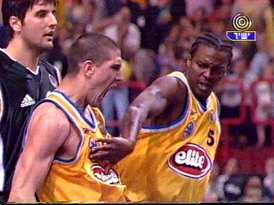  a | k | j | r | d | e | g | l | m | q
M | u | z | P | a | r | k | e | r | s | b | w
c | c | l | k | m | B | x | a | k | i | l | s
D | f | t | j | d | u | l | n | H | t | m | h
o | i | S | h | a | r | p | y | e | s | l | e
n | l | n | j | h | s | t | d | n | n | y | l
a | t | m | c | m | t | h | e | e | b | j | e
l | n | d | f | h | e | i | u | f | s | f | f
d | s | t | B | r | i | s | k | e | r | n | j
y | d | e | s | y | n | c | l | l | m | e | l
i | f | u | m | f | h | u | f | d | y | i | b
l | n | j | H | a | l | p | e | r | i | n | s
S | a | f | a | r | e | s | d | b | c | n | t

The names are:

McDonald, Parker, Henefeld, Safar, Brisker, Sharp, Shelef, Halperin and Burstein.

Written by:
Daniela Atami
Yehudit Tsinkin
Shelly Nadav
Yael Zavdi
Michal Hadad

