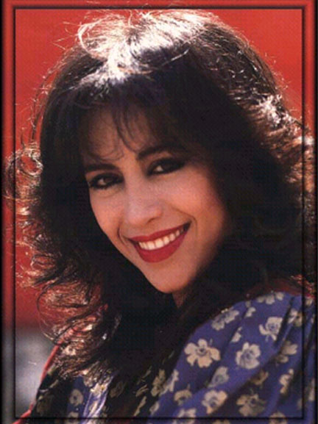

Born on 19 November 1957.

She served years in the national serevice in the Israeli army.
She recorded her first solo album in 1980.
In 1987 Haza survived when her airplane crashed
on the Israeli/Jordanian border.
She was voted second in the 1983 EUROVISION Song contest with
“Ani od Hai”.
Ofra a famous singer, she made her first movie with
“The Gashashim”’ and sang “Shir Hafrecha”.
This song a very popular song, and Haza was a big star.
She sang the of Moses’ mother in Dream works
star-studded animation the “Prince of Egypt”.
In 1994 Hasa recorded the last hebrew album.
It’s called "Kol Hanshama".
3 years later she married Doron Ashkenazi.
There was a big love between Ofra and Doron.
All these years she didn’t sing.
Most the time she stayed at home with Doron until she died.
Two years ago Haza come to "Shiva" hospital.
She was very weak.
Ofra died two weeks after she came to the hospital.
Her last song was "Forgiveness".
By: Mor Azani and Riki Elgrably

