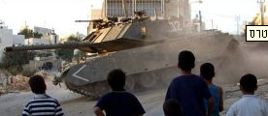
בס"ד

Introduction

We could write about the last terror attack, we could interview the President and ask the army about their next moves.

But no!

We decided to ask the simple people, those that nobody asks for their opinion but have a lot to say, meaning- us!.

Terror- what we think about it.

For those who don’t know, living in Israel is not easy. There are people who call it- “our situation”, but we need to dare and say- “war”.

You wake up in the morning, drink your coffee, make some toast, turn off the radio and hear the morning news- there was a terror attack!

You think to yourself - here comes another ordinary day. But if you stop for a moment and you understand that there are people for whom this day is not an ordinary one, that one man who dies has his own world- a world which was taken from us.

Maybe you wonder how we keep on smiling, laughing and mostly- living. But the answer is so simple! It’s right in front of us!

We’ll never give up!. We always go on living and if we have to, fighting for our country!

We learn in school about our fathers who fought for our country and the brave soldiers who scarificed their lives when they fought for the country, for us that we’ll have a place to live . We know that everything depends on us, and we can’t give up!

Names: Maayan Druzin, Reut Levi, Shani Meler, and Idit Morgenshteren.

