

In Israel there are many tourist centers.
We are going to present a few sites that in our opinion are the main sites in Israel.
The first site is Jerusalem:
Jerusalem is the capital city of Israel. Jerusalem is one of the beautiful cities in the world. A wonderful place for tourism and for vacation.
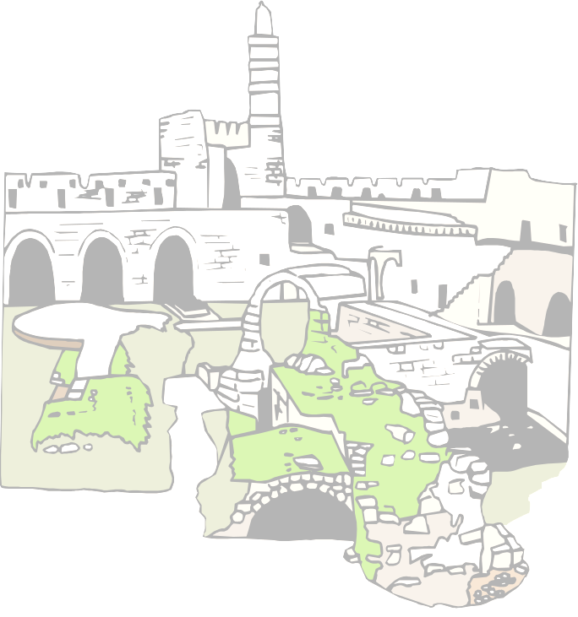
Jerusalem is a vibrant modern city with lively shopping malls and cultural activities like: music, theater and many sings, gnificamt museum, pubs, restaurants, night clubs etc.
Jerusalem is the holiest city for all these religions: the Islam, the Christianity and the Judaism.

The second site is Eilat.
Eilat is the most southern city of Israel. Eilat beats to the rhythm of the sun, the desert, the sea and the nature itself. The desert is impressive in its beauty: mountains, wadis and canyons.
In the sea of Eilat the water is clean and blue, and there are many fish in variety of colors. The temperature is always suitable for swimming and diving during the year.

Tiberias
Its location is on the waste shore of the sea of Kinerret. Tiberias is a favorite health and holiday resort. Tiberias lies on a mountain slope, beautifully looking over the Golan Heights.

The water of the Kinerret is pleasantly, clean and cool. The Kinerret supplies water for the people in Israel.
The last city that we chose to tell about is: Safed. A rather small town located in northern Israel. It has magnificent views east to the kinerret and the Jordan River. Its past is rich and great. Safed is one of the four holy cities in Israel. Safed is definitely a town of a Jewish soul. Its natural beauty and charm make Safed special.

So, did you already choose a site for a vacation in Israel?

By: Adi Albaz
Margalit Amsalem
Raut Madar
Michal Madar

