1) Which city is the
biggest in Israel ?
2) What is the national
theatre of Israel ?
3) What is the tallest mountain in Israel ?
4) Which city is holy for all three religions ?
5) Who was the first prime minister of Israel ?
6) Where is the diamond exchange in Israel ?
7) What is the lowest placein the world ?
8) what is thedistance between haifa and tel- aviv ?
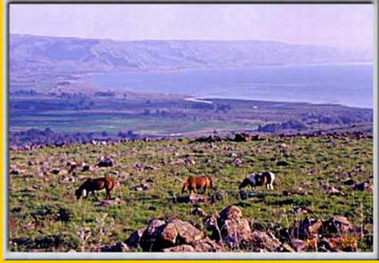
9) how many inhabitants are there in israel ?

1) jerusalem. 2) habima theatre.
3) hermon.
4) jerusalem.
5) ben gurion.
6) in ramat gan.
7) the dead sea.
8) 100 kilometers.
9) over 6 million.

Written by: reut levy,mayan druzin, shani meler and idit…

